# Introduction

## Company Profile

The company was set up as a manufacturer of interactive platforms and tools. The focus of our business is mainly on the user interface design and functionality of the product. Our products’ design specifications follow the trend adopted by the best field experts in software engineering as well as complying with the current industry standard.

Our team consist of highly trained and qualified engineers that constantly review and invent new methods to design higher quality product such as exquisite user interfaces and instructive functions.

## Vision

* To be the leading and cutting edge manufacturer of interactive platforms, designing innovative features and user friendly device.
* To understand and deliver products that consumers are most sort after.
* To create a better everyday life for everyone.
* To provide a world of solutions for the ever growing needs of the many.

# Roles and Responsibilities

## Organizational Structure

In order for any organization to fully operate at its fullest potential and capabilities, roles and responsibilities of each personnel in the company has to be established. Figure 1 below shows the organizational structure of the company.

The project manager carries the responsibility of ensuring that the group members work in concordance and harmony. Having to oversee that all the members of the company comply with the company’s policies and procedure is also part of the project manger’s responsibility.

As the roles mentioned down in the figure, each of them gets more into specialised operation whereby the products are being designed, tested, and strategize into the market. In order to ensure that a product is being delivered on schedule, communications between each team members is essential. This is done by having weekly meeting to review the progress of the production in each team and also consistently reviewing the deliverables and eventually every crucial milestone.

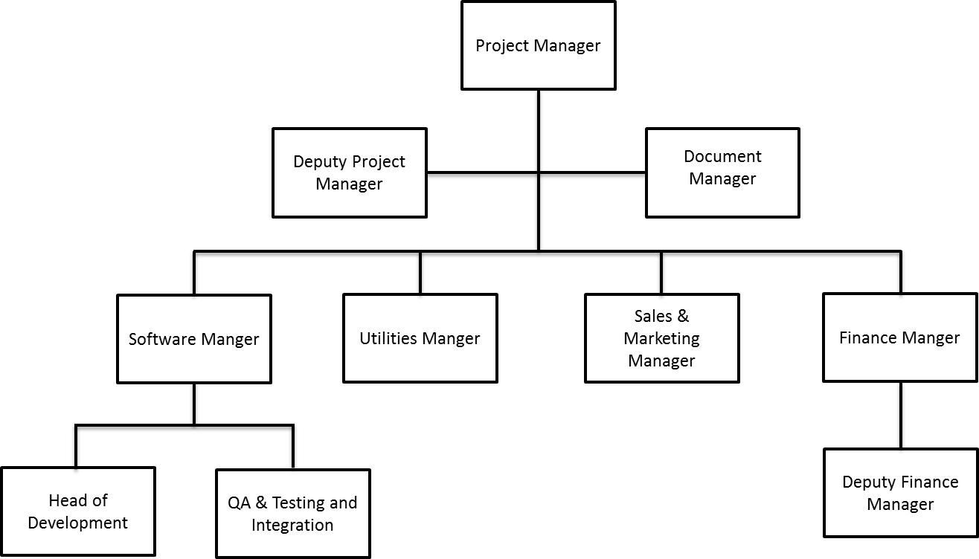

Figure 1 Organizational structure of the company

## Project Manager

### Role Description

The Project Manager is responsible for taking an overviewing role within the company and organising the working of the team toward the desired goals. She along with the Deputy Project Manager is accountable for insuring that the design, development and implementation process runs smoothly during the project life cycle (section 4) until the final product is presented to the customer. Accomplishing this involves several tasks that include:

* Arranging for regular meetings with the team and chairing meetings.
* Along with the Deputy Project Manager having the ability to make the final decisions in case of a dispute, disagreement or otherwise.
* Provide meeting agendas (see Appendix A for templates).
* Signing monthly Timesheets and working closely with the Business Manager to ensure the Business Plan is being conformed to.
* Assigning the different roles required in the project in a way that ensures the optimal use of every member’s qualifications is reached.
* Maintaining an encouraging and cooperative environment where every individual contribution is appreciated and respected.
* With the help of the Software Manager, provide the plans for the project development and monitor the progress.
* With the help of the appropriate managers, provide the timetable plan and ensure it is adhered to, or make appropriate modifications as required.
* Make sure that the requirements and standards are met at every stage whether during the development process itself or when the final product is near completion.
* Providing solutions and backup strategies where required.
* Grant final approval of all the deliverables provided by the team.
* Deliver reports to customers and act as the connection between them and the project team.
* Produce the overall project plan (with Gantt Chart) and time schedule.

### Risk Management

|  |  |
| --- | --- |
| Risk | Possible Solution |
| Some group members don’t get along with each other. | Try to resolve any issues that group members might have. If this does not work, consider assigning and delegating tasks to minimise disruption within the group as a whole. |
| The prolonged absence of a member in the group. | Have more than one team member trained to do any task. Be ready to adjust schedules as appropriate. |
| Deadline overdue. | Have regular project plan review meetings where possible overruns can be identified and rescheduling can be considered. |
| Failure to meet one of the requirements. | Have regular review meetings where requirement conformity is checked. Make sure that the design and the development of the product is organized in a way that simplifies rollback and re-implements the missing requirements with as little modification to other parts as possible. |
| Finding out late during the project that one member has a lot more work than the others. | Review the workload for each member regularly to make sure there is a parity in the amount of work done by each person. |
| Certain team members producing work that is not up to the mark or not doing any work altogether. | Have a system to review work done by each member (as mentioned above) and hold separate meetings with the members in question. If even after repeated counselling there is no change, talk to the board members (in this case Dr. Stuart Porter and the supervisor) to take further action. |

### Quality Assurance Metrics

|  |  |
| --- | --- |
| Metric | How measured |
| Client requirements clarity. | Holding regular meetings ensuring that the client understands his/her own requirement statements and that these have been interpreted correctly by the company and finally signed off by both sides. |
| Project wide standards and contracts drawn up and adhered to. | Working with other teams to finalise PWS and liaising with the client and other teams for final contracts. |
| Complete specification. | Checking the specifications against the requirements statement to make sure all requirements are covered by the specifications team, during appropriate review meeting(s). |
| Software and Business Plan clarity. | Holding review meetings to make sure software plans and business plans are at par with each other. |
| Deadlines met. | Deliverables submitted as timetabled and recorded. |

## Deputy Project Manger

### Role Description

### Risk Management

### Quality Assurance Metrics

## Document Manger

### Role Description

### Risk Management

### Quality Assurance Metrics

## Software Manger

### Role Description

### Risk Management

### Quality Assurance Metrics

## Head of Development

### Role Description

### Risk Management

### Quality Assurance Metrics

## Quality & Testing and Integration Manager

### Role Description

### Risk Management

### Quality Assurance Metrics

## Utilities Manager

### Role Description

### Risk Management

### Quality Assurance Metrics

## Sales & Marketing Manager

### Role Description

### Risk Management

### Quality Assurance Metrics

## Finance Manager

### Role Description

### Risk Management

### Quality Assurance Metrics

## Deputy Finance Manger

### Role Description

### Risk Management

### Quality Assurance Metrics